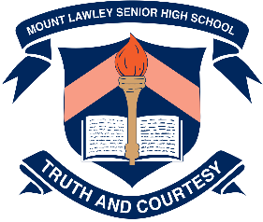**Year 8 Chemical Science 2022**

**Elements and Compounds Multiple Choice Questions**

1. **Which of the following statements regarding Dalton’s atomic theory is not true:**
   1. All matter is made up of hard, tiny, invisible particles called atoms.
   2. Substances made from one type of atoms are known as compounds.
   3. The atoms of different elements can be distinguished by their different masses.
   4. Atoms can combine to form new substances called molecules.
2. **Alkali Earth metals are represented in Group**
   1. 2
   2. 7
   3. 8
   4. 9
3. **A bottle contains pure hydrogen gas H2. Which of these statements are true.**
4. The bottle contains only one element.
5. The bottle contains individual atoms.
6. The bottle contains 2 molecules.
7. H2 is a compound.
8. **The chemical formula for sulphuric acid is H2SO4. Which of these statements is true?**
9. Sulphuric acid is an element.
10. Sulphuric acid contains two different elements.
11. There are more Sulphur atoms than Hydrogen atoms in sulphuric acid.
12. Sulphuric acid is a compound.
13. **Which is the best definition of a molecule?**
14. A cluster of atoms.
15. A network of atoms bonded together.
16. A cluster of two or more atoms bonded together.
17. A substance made of single atoms.
18. **Which of these contains only compounds:**
19. N2, CO2, CH3COOH, NaCl
20. MgO, CO, H2O, H2SO4
21. C60, O2, S8, P4
22. Au, He, Mg, Cu

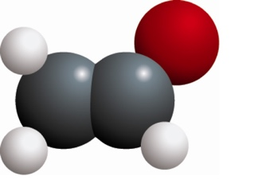

1. **Identify what the chemical structure shown here represents**
2. A molecular element.
3. A lattice element.
4. A molecular compound.
5. A lattice compound.
6. **An atom consists of:**
7. a nucleus containing neutrons and protons, surrounded by a cloud of electrons.
8. central neutrons, surrounded by a cloud of electrons and protons.
9. electrons, surrounded by a cloud of protons.
10. a mixture of protons and electrons spread evenly in a neutral ‘dough’.
11. **Which of the following statements regarding atomic particles is false?**
12. Protons are found in the nucleus and are positively charged particles.
13. Electrons move around the nucleus and contribute little to the mass of the atom.
14. Neutrons are found in the nucleus, and they have no charge.
15. The numbers of neutrons, protons and electrons are always equal in an atom.
16. **Identify which list contains only properties of metals.**
17. brittle, conduct heat, conduct electricity
18. malleable, electrical insulator, ductile
19. dull appearance, crumble, gas at room temperature
20. ductile, malleable, conduct electricity
21. **The following statements about elements are all true:**

* Elements are substances made up of just one type of atom.
* The atoms in elements can form molecules or crystal lattices.
* Elements can be metallic or non-metallic.
* Solid, non-metallic elements can be made up of molecules or crystal lattices.
* All solid, metallic elements are made up of crystal lattices.

**From this information you can deduce:**

1. A crystal lattice is always metallic.
2. A solid, non-metal element is always made up of molecules.
3. A solid element made up of molecules cannot be metallic.
4. A solid, non-metal is never made up of a crystal lattice.
5. **The chart below divides elements into 5 groups where the letters V, W, X, Y and Z represent an example of each.**

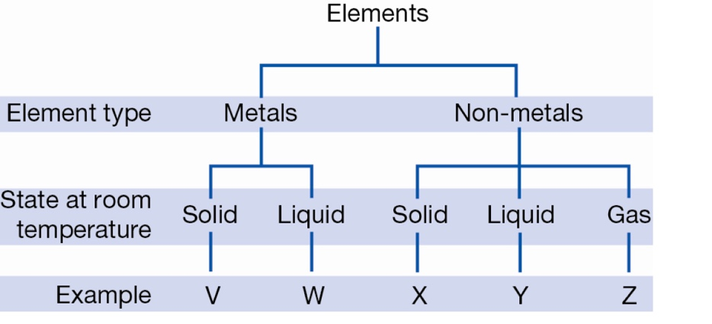**Given that bromine is the only non-metal liquid at room temperature, it can be inferred that bromine could be:**

1. Y only
2. W or Y
3. W only
4. X, Y or Z
5. **The conductivity of a metal is a measure of how well the metal transmits an electrical current. Usually, the conductivity will change with temperature as shown for four metals in the graph below.**

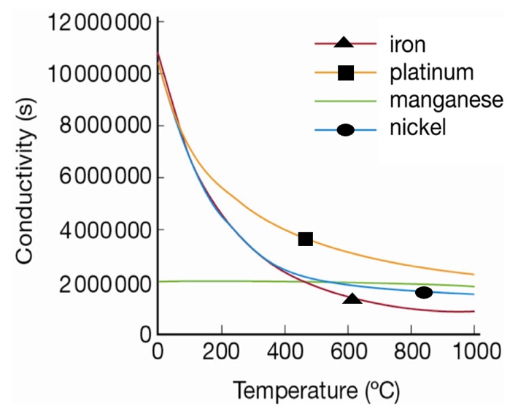 **According to this graph, the best conductor at 700°C is:**

a. iron

b. platinum

c. manganese

d. nickel

1. **Elements in the periodic table are arranged in order of:**
2. decreasing atomic number.
3. decreasing mass number.
4. increasing atomic number.
5. increasing mass number.
6. **Table sugar (sucrose) has the formula C12H22O11. How many atoms are there altogether?**
7. 3
8. 17
9. 30
10. 45
11. **Which of the following is not a property of metals?**
12. Ductile
13. Malleable
14. Good electrical conductivity
15. Having a dull appearance.
16. **Chemists use symbols to identify each element. Recall which feature is true of these symbols.**

a. They mostly contain one or two letters.

b. They always use the first letter of the element name.

c. They are arranged in the periodic table alphabetically.

d. They must use only capital letters.

1. **Determine which of the following statements about molecular compounds is true.**

a. The atoms in a molecular compound are all the same.

b. The molecules contain the same types of atoms but may have different numbers of each type.

c. The molecules contain more than one type of atom.

d. The molecules don’t have a formula.

1. **Which of the following lists contain only elements?**
2. aluminium, carbon dioxide, copper
3. iron oxide, carbon monoxide, boron
4. kerosene, hydrogen, mercury
5. manganese, hydrogen, lithium, boron
6. **Given that an atom has 26 protons and 30 neutrons. Its atomic symbol would be:**

30

26

Fe

56

26

Fe

A B

26

56

Fe

Fe

26

26

C D

1. **Which one of the following elements is a non-metal?**
   1. Iron
   2. Sulfur
   3. Zinc
   4. Copper
2. 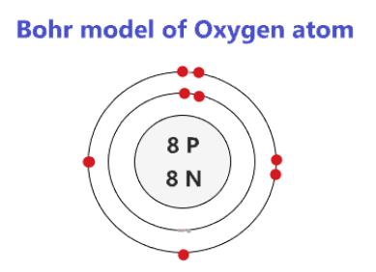**The below atom is constructed using Bohr’s Planetary Model. Which element does this atom belong to?**
   1. Hydrogen
   2. Sodium
   3. Neon
   4. Oxygen
3. 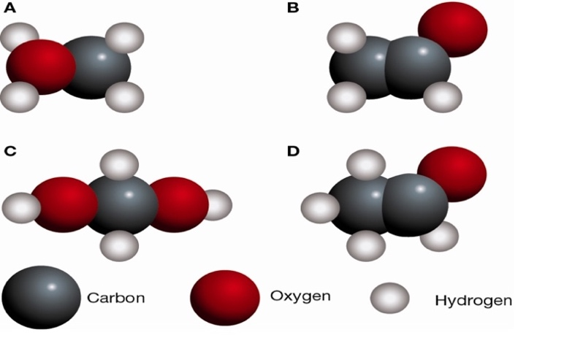 The molecular formula for a compound tells you what type of atoms are in the molecules and how many of each. For example, the molecular formula for water H2O tells you that there are two hydrogen atoms (H) and one oxygen atom (O) in each molecule of water.

**A common compound found in coffee, bread  
and ripe fruit is acetaldehyde, which has the  
molecular formula C2H4O.**

**Which of the following diagrams would best  
represent a molecule of acetaldehyde?**

1. **Copper, iron and chlorine are all:**
   1. Mixtures
   2. Compounds
   3. Elements
   4. metals
2. **The correct symbols for the element’s helium, hydrogen, magnesium and beryllium in order are:**
3. Hg He Mn B
4. He Hn Mn Be
5. H He Mg B
6. He H Mg Be
7. **Which of the following gives the correct charge of protons, electrons and neutrons?**
   1. PROTONS - negative, ELECTRONS - positive, NEUTRONS – neutral
   2. PROTONS - neutral, ELECTRONS - positive, NEUTRONS – negative
   3. PROTONS - positive, ELECTRONS - negative, NEUTRONS – neutral
   4. PROTONS - negative, ELECTRONS - neutral, NEUTRONS – positive
8. **Water is an example of a compound because it**
   1. is made of atoms.
   2. is a mixture of atoms.
   3. has two different kinds of atoms joined together.
   4. is a solid.

**Use the chemical equation below to answer questions 28 and 29.**

Products

Reactants

**CuSO4 + Na2CO3 CuCO3 + Na2SO4**

1. **In the chemical equation above, the type and number of atoms in the reactants is:**
2. 4 copper atoms, 4 carbon atoms, 2 sodium atoms, 1 sulphur atom and 2 oxygen atoms
3. 1 copper atom, 1 carbon atom, 2 sodium atoms, 1 sulphur atom and 7 oxygen atoms
4. 1 copper atom, 3 carbon atom, 2 sodium atoms, 1 sulphur atom and 7 oxygen atoms
5. 1 copper atom, 4 carbon atoms, 2 sodium atoms, 1 sulphur atom and 3 oxygen atoms
6. **In the chemical equation above, the type and number of atoms in the products is:**
7. 4 copper atoms, 4 carbon atoms, 2 sodium atoms, 1 sulphur atom and 2 oxygen atoms
8. 1 copper atom, 1 carbon atom, 2 sodium atoms, 1 sulphur atom and 7 oxygen atoms
9. 1 copper atom, 3 carbon atom, 2 sodium atoms, 1 sulphur atom and 7 oxygen atoms
10. 1 copper atom, 4 carbon atoms, 2 sodium atoms, 1 sulphur atom and 3 oxygen atoms
11. **Identify which of the following is false about The Periodic Table**
    1. Group one contains highly reactive metals known as alkali metals.
    2. Noble gases are unreactive .
    3. Transition metals are smallest family of metals.
    4. There are more metallic than non-metallic elements.

|  |  |
| --- | --- |
| Mount Lawley Senior High School - Wikipedia | **Mount Lawley Senior High School** |
| **Year 8 2022 – Chemical Science – Elements and Compounds Test** |
| Name: ___________________________________________________________  Class: _____________________________ Date:_____________________ |

***Section A: Multiple Choice – Please shade the best suited answer* 30 marks**

1. A B C D
2. A B C D
3. A B C D
4. A B C D
5. A B C D
6. A B C D
7. A B C D
8. A B C D
9. A B C D
10. A B C D
11. A B C D
12. A B C D
13. A B C D
14. A B C D
15. A B C D
16. A B C D
17. A B C D
18. A B C D
19. A B C D
20. A B C D
21. A B C D
22. A B C D
23. A B C D
24. A B C D
25. A B C D
26. A B C D
27. A B C D
28. A B C D
29. A B C D
30. A B C D

**Multiple Choice: ________ /30**

**Short Answer: ________ / 32**

**TOTAL: ________ / 62**

***Section B: Short Answer – Please write your answers in the space provided 32 marks***

1. **a) What is a “Period” on The Periodic Table?** (1 mark)

The rows

**b) What do elements within the same period have in common?** (1 mark)

All elements in the same row have the same number of electron shells. ’Orbital’ is not technically correct

Follow through: if ‘column’ for part A then answer for part B should be: same ionic charge/valence electron

1. **a) Write the name or chemical symbol for each of the elements below.**  (4 Marks)

Sodium: Na Beryllium: Be Silicon: Si Phosphorus: P (1/2 mark each)

K: Potassium B: Boron Ar: Argon S: Sulphur

1. **Name the elements that make up the following compounds**. (2 Marks)

Ammonium chloride - NH4Cl Nitrogen, Hydrogen, Chlorine (1) NO HALF MARKS FOR THIS Q

Aluminium hydroxide - Al (OH)3 Aluminum, Oxygen, Hydrogen (1)

1. a) Calculate **the number of protons, neutrons and electrons in an atom with the atomic symbol:** (3 marks)

Protons: 17

Cl

35

17

Neutrons: 18

Electrons: 17

**b) Draw a LABELLED diagram of this atom including the number protons, neutrons and electrons in the correct locations:** (3 marks)

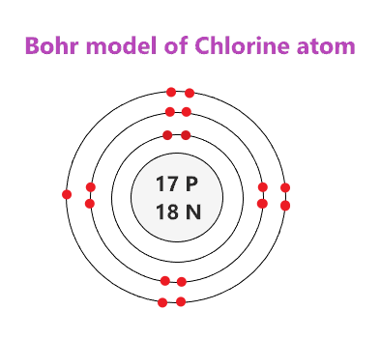

1 mark for correct protons and neutrons in a nucleus

1 mark for correct number of shells

1 mark for correct number of electrons in each shell  
(2 in first, 8 in second, 7 in third)

1. ***Propanol has the molecular formula C3H8O.***

Determine **the type of atoms in each molecule and the total number of each type of atom.** (3 marks)

Carbon – 3 Hydrogen - 8 Oxygen – 1 ½ for correct element

½ for correct number

1. **Name** **the element that is present in all of the following compounds.** (1 mark)

SO2, H2S, H2SO4, CuSO4

Sulphur

1. Diagram

   Description automatically generated **Determine** **the chemical formula for the molecules shown below.** (2 marks)

1. NH3 or H3N b) CO2 or O2C
2. **The following table shows information about three different elements. Use the information given in the table to help you fill in the missing details.** (6 marks)

|  |  |  |  |  |  |  |
| --- | --- | --- | --- | --- | --- | --- |
| Atom | Atomic number | Mass number | Number of protons | Number of neutrons | Number of electrons | Symbol for the atom |
| Gold | 79 | 197 | 79 | 118 | 79 | Au |
| Oxygen | 8 | 16 | 8 | 8 | 8 | O |
| Helium | 2 | 4 | 2 | 2 | 2 | He |

½ mark for each correct

1. **The diagram below shows model of salt ( NaCl )**
2. 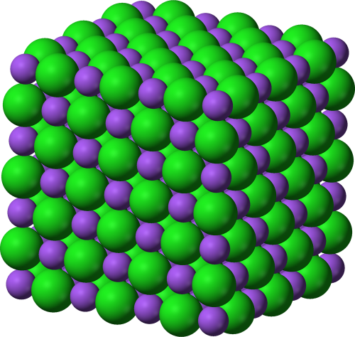**Describe what is meant by the word “lattice”** (1 mark)

A grid-like structure of atoms (1 mark) that are bonded together and arranged in a continuous pattern

1. **Is salt an element or a compound?   
   Explain your answer** (2 marks)

Compound (1 mark)

Because it is made from 2 different types of atoms bonded together

(1 mark)

1. **Describe how a molecular element is different to a molecular compound** (2 marks)

A molecular element contains 2 or more of the SAME atoms chemically bonded together (1 mark) while a molecular compound contains 2 or more DIFFERENT atoms chemically bonded together (1 mark)

1. **The list below shows properties that different elements can have.**  (1 mark)

• good conductor of electricity • very high melting point.

• poor conductor of electricity • very low melting point.

• poor conductor of heat • magnetic

• good conductor of heat • can be compressed

**Which two properties from the list above make aluminum suitable for saucepans?**

1. Good conductor of heat (1/2 mark) 2. Very high melting point (1/2 mark)